XPPL Web Application

<http://xppl-wms.phonesackgroup.com:833/login>

Register the web

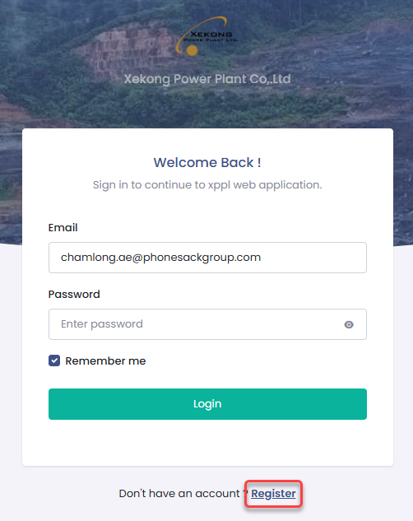

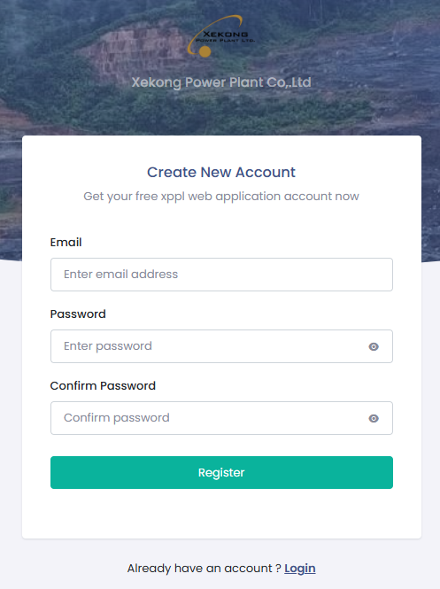

Note: If you are a phonsackgroup employee, you may register using your corporate email; otherwise, you must first request that the administrator register your email in the database.

Login to the web application

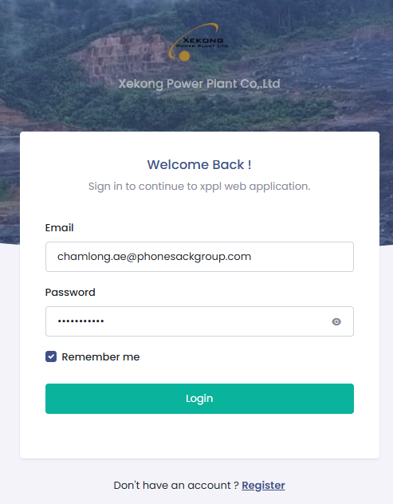

Contract the administrator to provide you the atheization.

